**Developing Potential Agriculture Land Detector For Production Of Peanut Plant Using Raspberry-Pi**

**Aim:**

Precision agriculture is that the mechanism that controls the land productivity and maximizes the revenue and minimizes the impact on surroundings by automating the entire agriculture processes. This projected work depends on freelance internet of things (IoT) enabled wireless sensing element network (WSN) framework consisting of soil wetness (MC) probe, soil temperature measuring system, environmental temperature sensing element, environmental humidness sensing device, CO2 sensor, daylight intensity device (light dependent resistor) to accumulate period of time farm info through multi-point activity.

The projected observance technique consists of all standalone IoT-enabled WSN nodes used for timely information acquisitions and storage of agriculture info. The farm history is in addition keep for generating necessary action throughout the whole course of farming. The work summarizes the optimum usage of irrigation by the precise management of water valve mistreatment neural network-based prediction of soil water demand in one h ahead. Our planned irrigation management scheme utilizes structural similarity (SSIM)-based water valve management mechanism that is employed to find farm regions having water deficiency. Moreover, an in depth comparative study of improvement techniques, like variable learning rate gradient descent, gradient descent for feed forward neural network-based pattern classification, is performed and also the best follow is utilized to forecast soil megacycle per second on hourly basis alongside interpolation methodology for generating soil moisture content (MC) distribution map. Finally, SSIM index-based soil megacycle per second deficiency is calculated to control the specified valves for maintaining uniform water demand through the complete farm space. The valve management commands are again processed mistreatment fuzzy logic-based weather modeling system {to manipulate| to management| to govern} control commands by considering completely different climatic conditions.

**Hardware & Software Requirement:**

1. Raspberry Pi
2. Power Source
3. Battery Management System
4. Zig Bee transceivers
5. Soil MC Sensor
6. Soil Temperature Sensor
7. Environmental Temperature Sensor
8. Humidity Sensor
9. Sunlight Sensor

**Project Flow:**

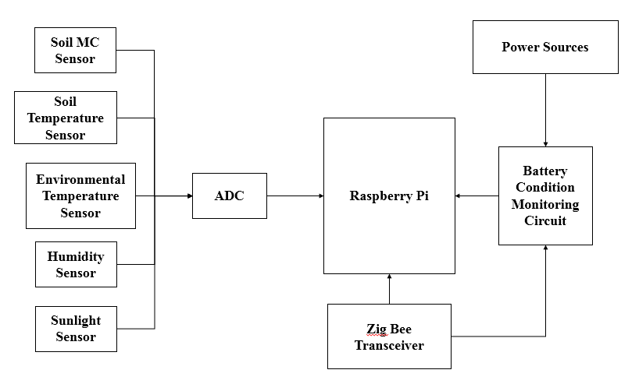

**Proposed Model:**

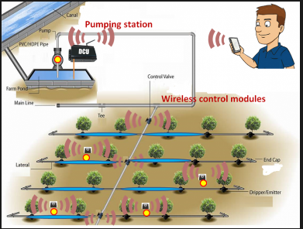

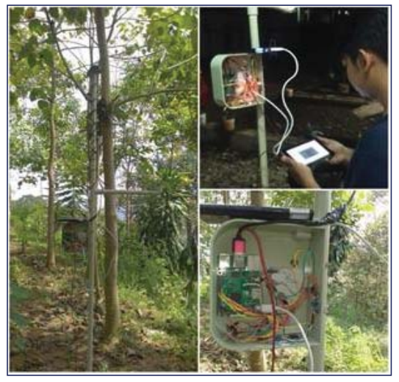

**Stake Holders:**

-The main stake holders are those farmers who are interested in planting peanuts as this would help them to guide which part of land is better to plant for cropping and moreover it gives a brief data on how much minerals content is available on soil.

Then comes the distributors or the commercials who manufacture these prototypes as they can trade with these product and moreover they try to make the prototype look so attractive that it would make the consumers an interest towards the product.

Finally comes the researchers who work on these prototype to make it simpler, better and affordable to everyone as it could reach to many people who are not aware of these stuff.